ASSIGNMENT 6 - PYTHON OOP & FILE HANDLING
Name: MOHAMMED ADNAN
Roll No: 2503B05107

Task 1: Student Class
Explanation:
This task demonstrates class creation, constructor usage and object instantiation.
Code:
class Student:
def __init__(self, name, roll, dept):
self.name = name
self.roll = roll
self.dept = dept
def display_details(self):
print("\n----- Student Details -----")
print("Name:", self.name)
print("Roll Number:", self.roll)
print("Department:", self.dept)
name = input("Enter student name: ")
roll = input("Enter roll number: ")
dept = input("Enter department: ")
student1 = Student(name, roll, dept)
student1.display_details()
Output Screenshot:
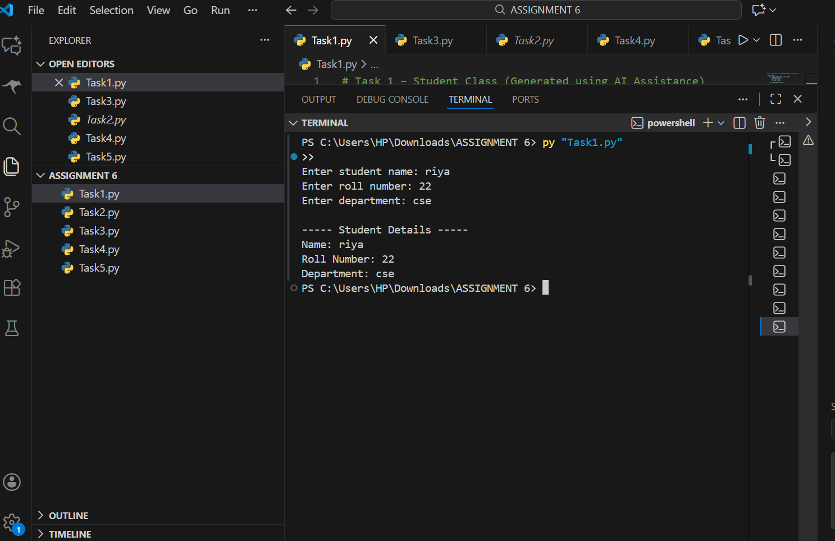

Task 2: Inheritance in Python
Explanation:
This task shows inheritance where Student inherits from College class.
Code:
class College:
def __init__(self, college_name, location):
self.college_name = college_name
self.location = location
def display_college(self):
print("\n----- College Details -----")
print("College Name:", self.college_name)
print("Location:", self.location)
class Student(College):
def __init__(self, college_name, location, name, roll, dept):
super().__init__(college_name, location)
self.name = name
self.roll = roll
self.dept = dept
def display_student(self):
print("\n----- Student Details -----")
print("Name:", self.name)
print("Roll Number:", self.roll)
print("Department:", self.dept)
Output Screenshot:
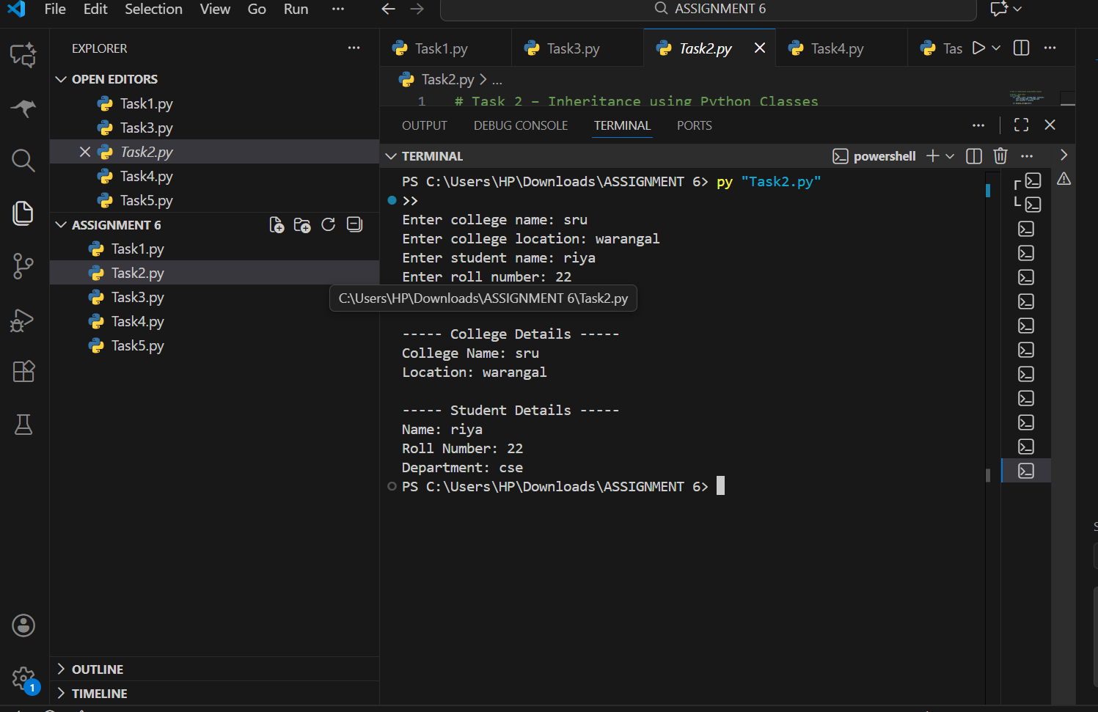

Task 3: Polymorphism
Explanation:
Shows method overriding and runtime polymorphism using Animal, Dog, Cat classes.
Code:
class Animal:
def sound(self):
print("Animals make sound")
class Dog(Animal):
def sound(self):
print("Dog barks Woof!")
class Cat(Animal):
def sound(self):
print("Cat meows!")
Output Screenshot:
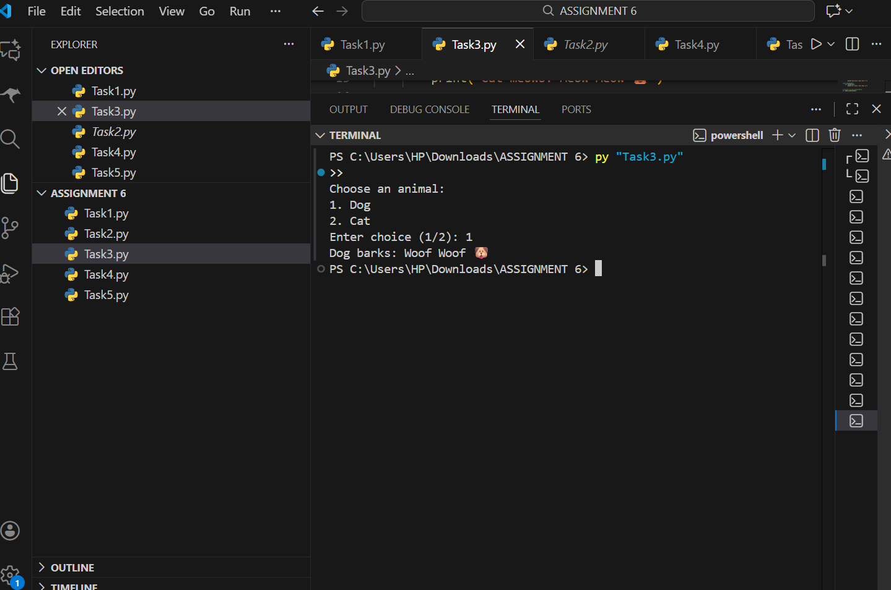

Task 4: File Handling
Explanation:
This task writes user input to file and reads content using Python file handling.
Code:
with open("student_data.txt","w") as f:
f.write("sample text")
with open("student_data.txt","r") as f:
print(f.read())
Output Screenshot:
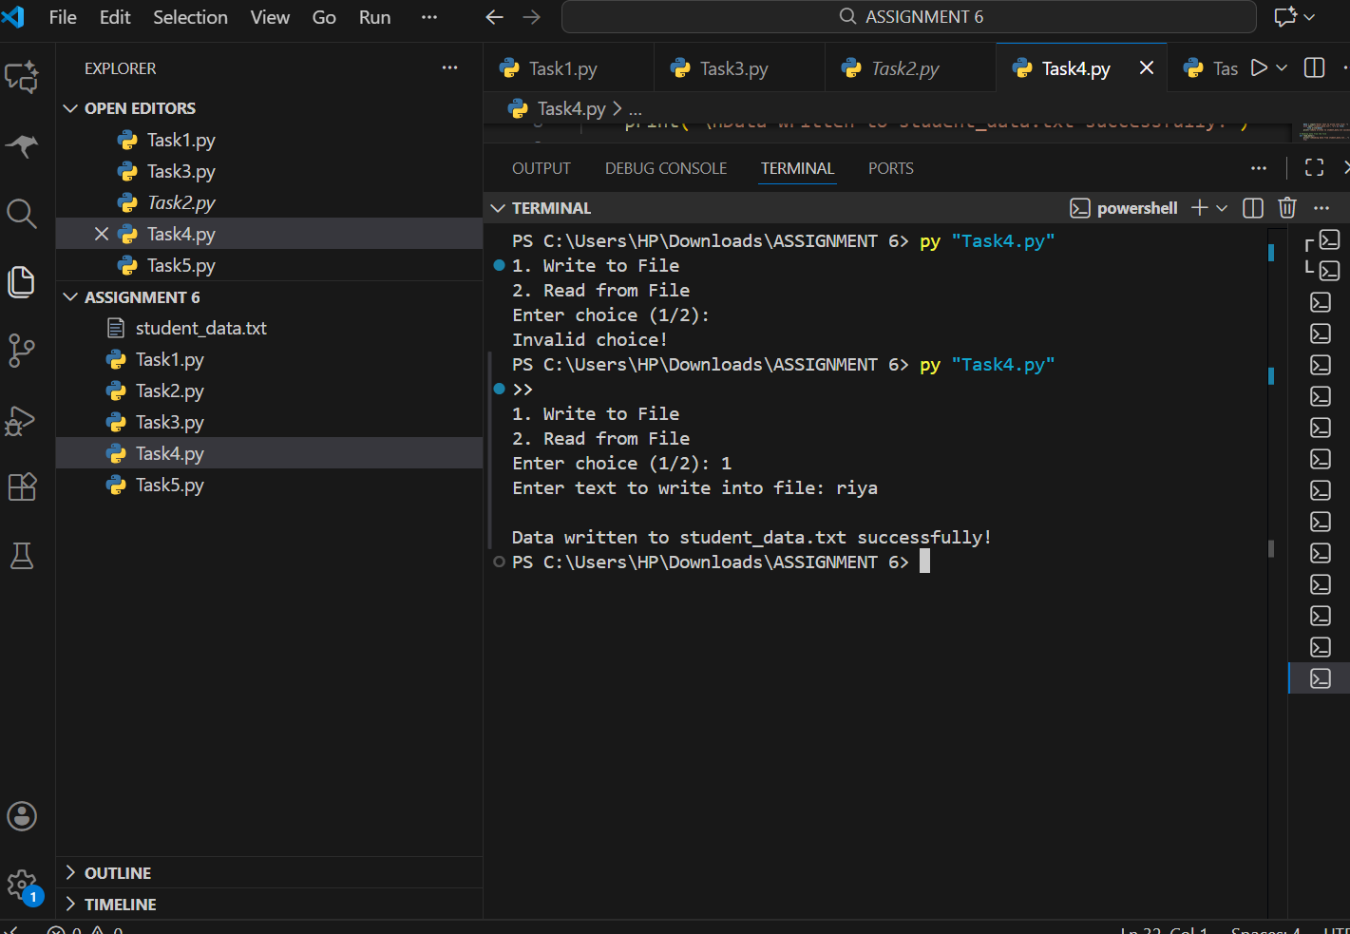

Task 5: Exception Handling
Explanation:
Implements try-except-finally block to safely handle errors.
Code:
try:
a=int(input())
b=int(input())
print(a/b)
except ZeroDivisionError:
print("Division error")
finally:
print("Done")
Output Screenshot:
